**Homework Solutions**

5.4: (a) The scatterplot is shown. (b) The regression equation is ˆ y = 201.2 + 24.026x. (c) The slope tells us that on the average, metabolic rate increases by about 24 calories per day for each additional kilogram of body mass. (d) For x = 45 kg, the predicted metabolic rate is ˆ y = 1282.4 calories per day.

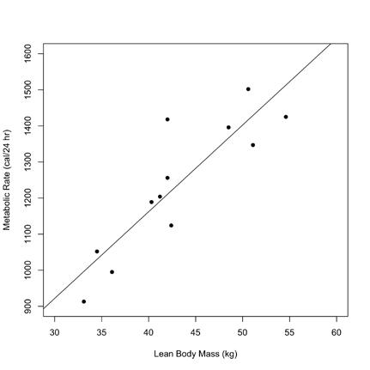

5.13: (a) The regression line is ˆ y = –43.172 + 0.129x. (b) If 975,000 boats are registered, then by our scale, x = 975, and ˆ y = –43.172 + (0.129)(975) = 82.6 manatees killed. The prediction seems reasonable, as long as conditions remain the same, because “975” is within the space of observed values of x on which the regression line was based. That is, this is not extrapolation. (c) If x = 0 (corresponding to no registered boats), then we would “predict” –43.172 manatees to be killed by boats. This is absurd, since it is clearly impossible for fewer than 0 manatees to be killed. This illustrates the folly of extrapolation… x = 0 is well outside the range of observed values of x on which the regression line was based.